Spring MVC – Hello Program.
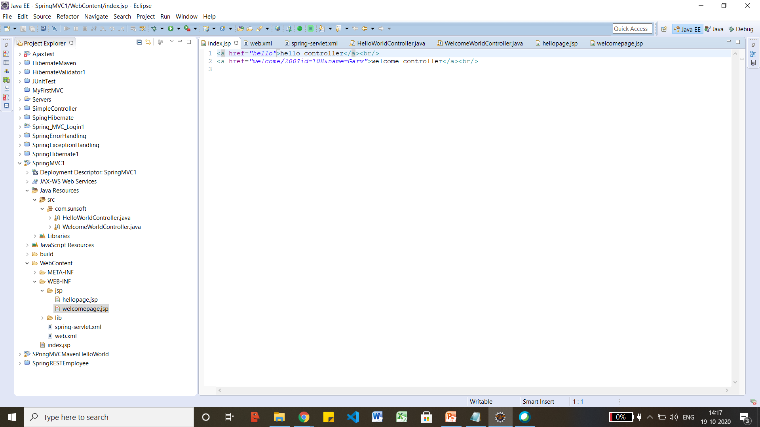
<?xml version="1.0" encoding="UTF-8"?>
<web-app version="2.5" xmlns="http://java.sun.com/xml/ns/javaee"
xmlns:xsi="http://www.w3.org/2001/XMLSchema-instance"
xsi:schemaLocation="http://java.sun.com/xml/ns/javaee
http://java.sun.com/xml/ns/javaee/web-app_2_5.xsd">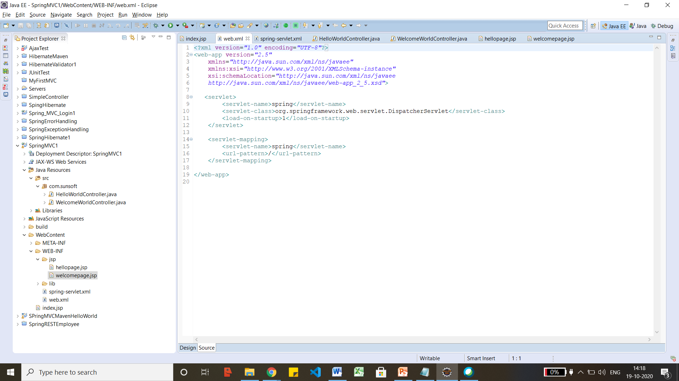

<?xml version="1.0" encoding="UTF-8"?>
<beans xmlns="http://www.springframework.org/schema/beans"
xmlns:xsi="http://www.w3.org/2001/XMLSchema-instance"
xmlns:p="http://www.springframework.org/schema/p"
xmlns:context="http://www.springframework.org/schema/context"
xsi:schemaLocation="http://www.springframework.org/schema/beans
http://www.springframework.org/schema/beans/spring-beans-3.0.xsd
http://www.springframework.org/schema/context
http://www.springframework.org/schema/context/spring-context-3.0.xsd">
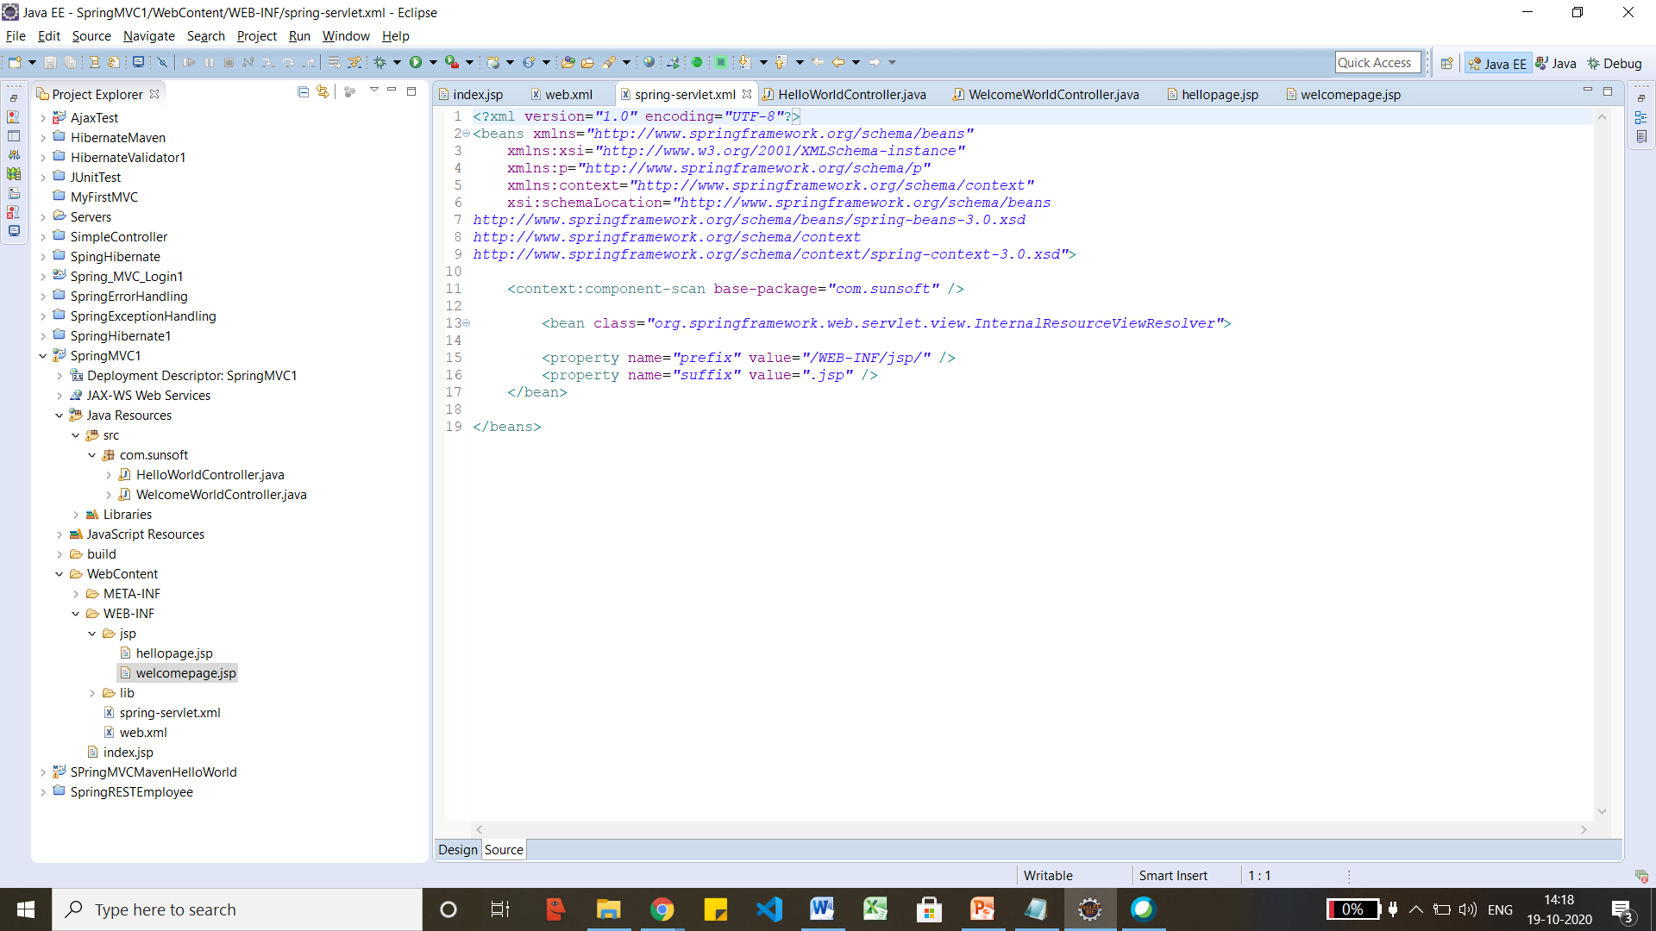
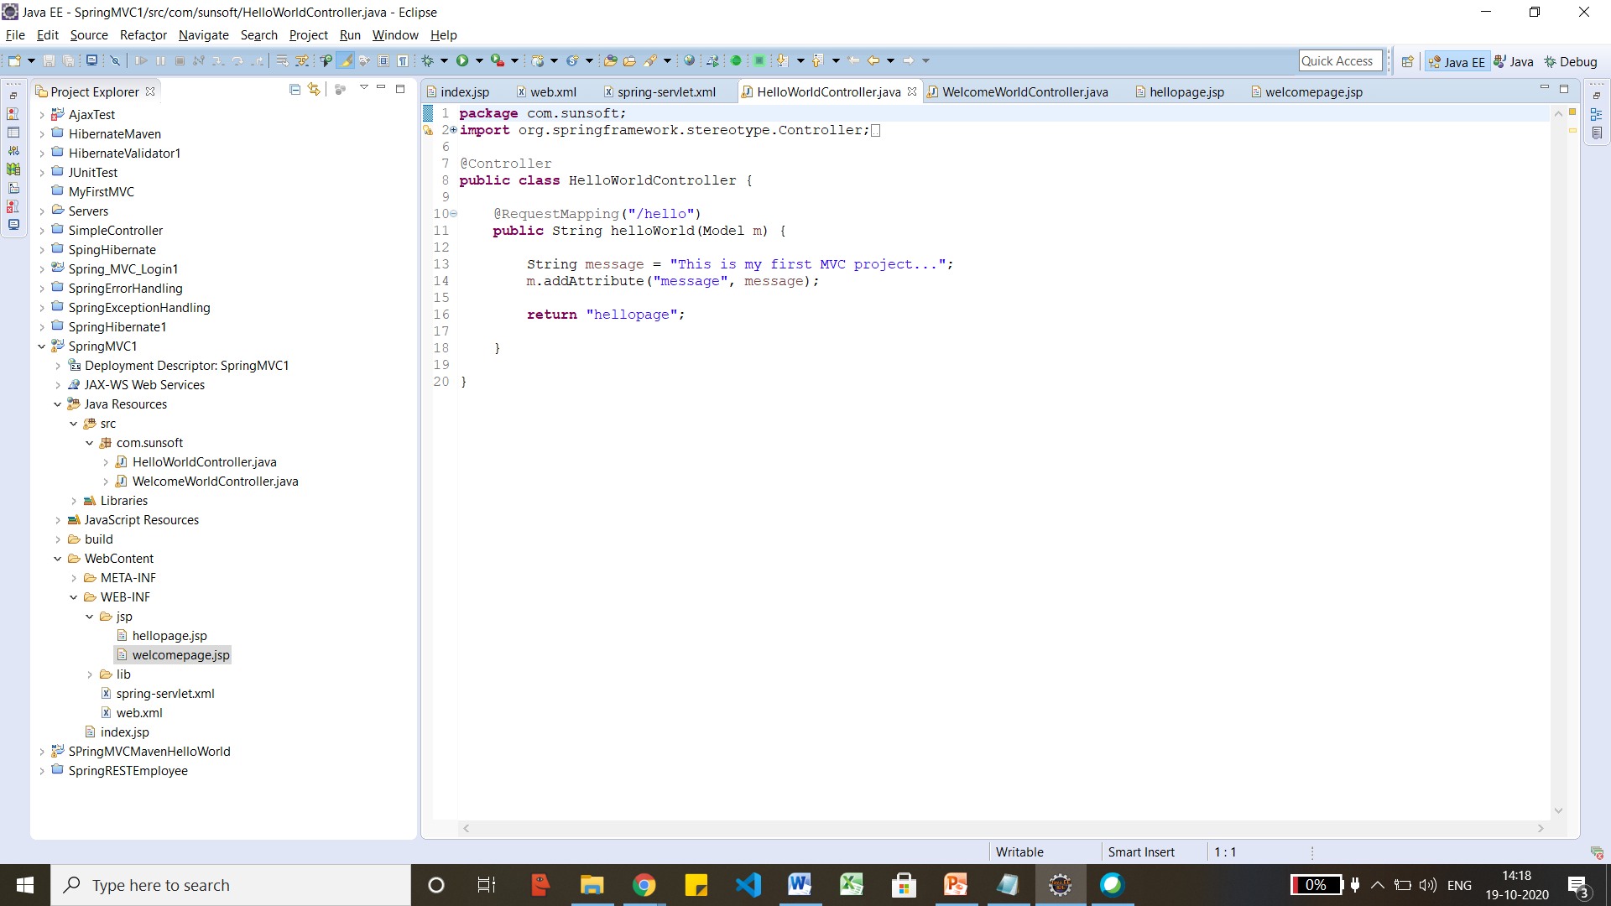
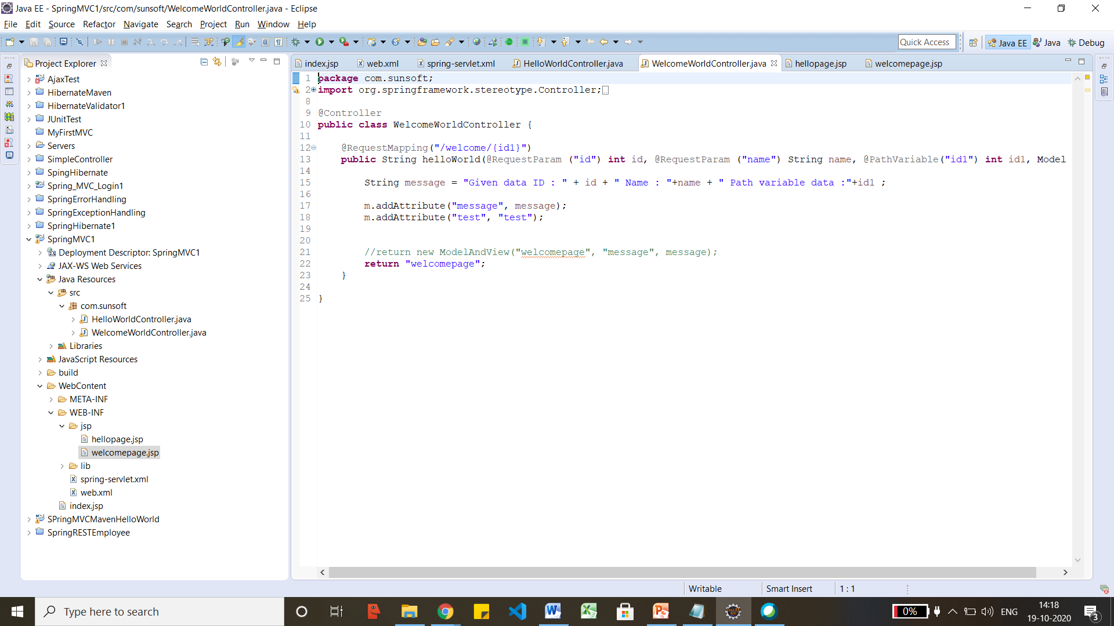
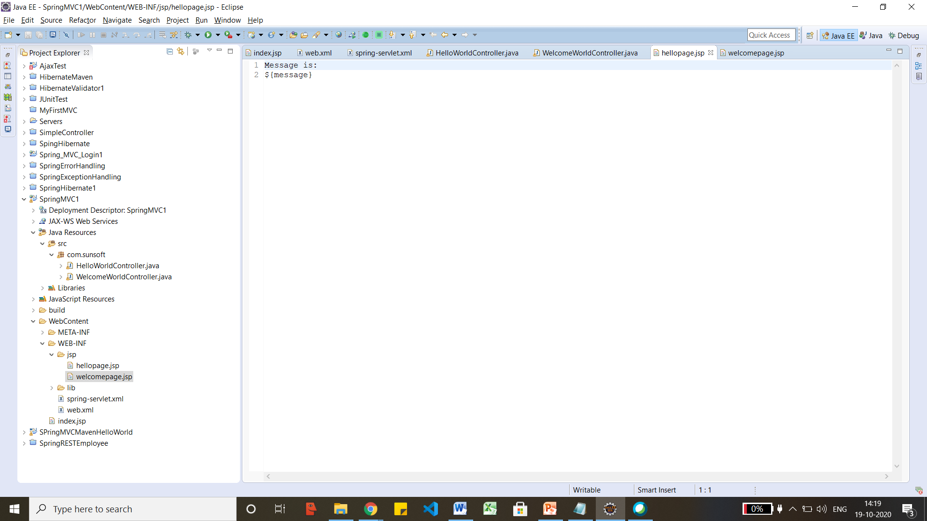
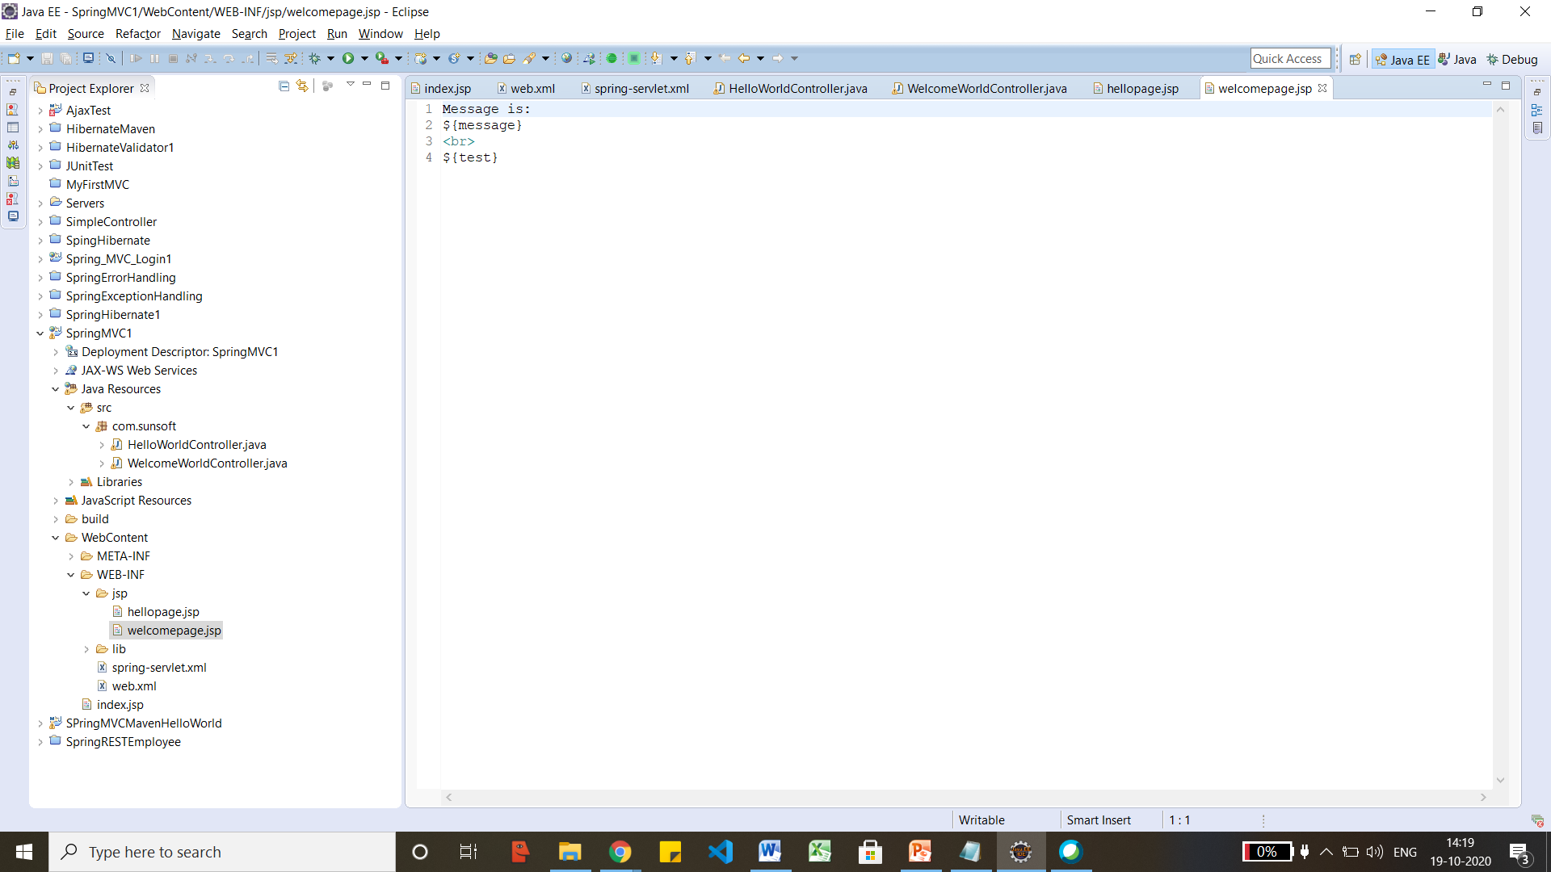

Spring Loging form validation.
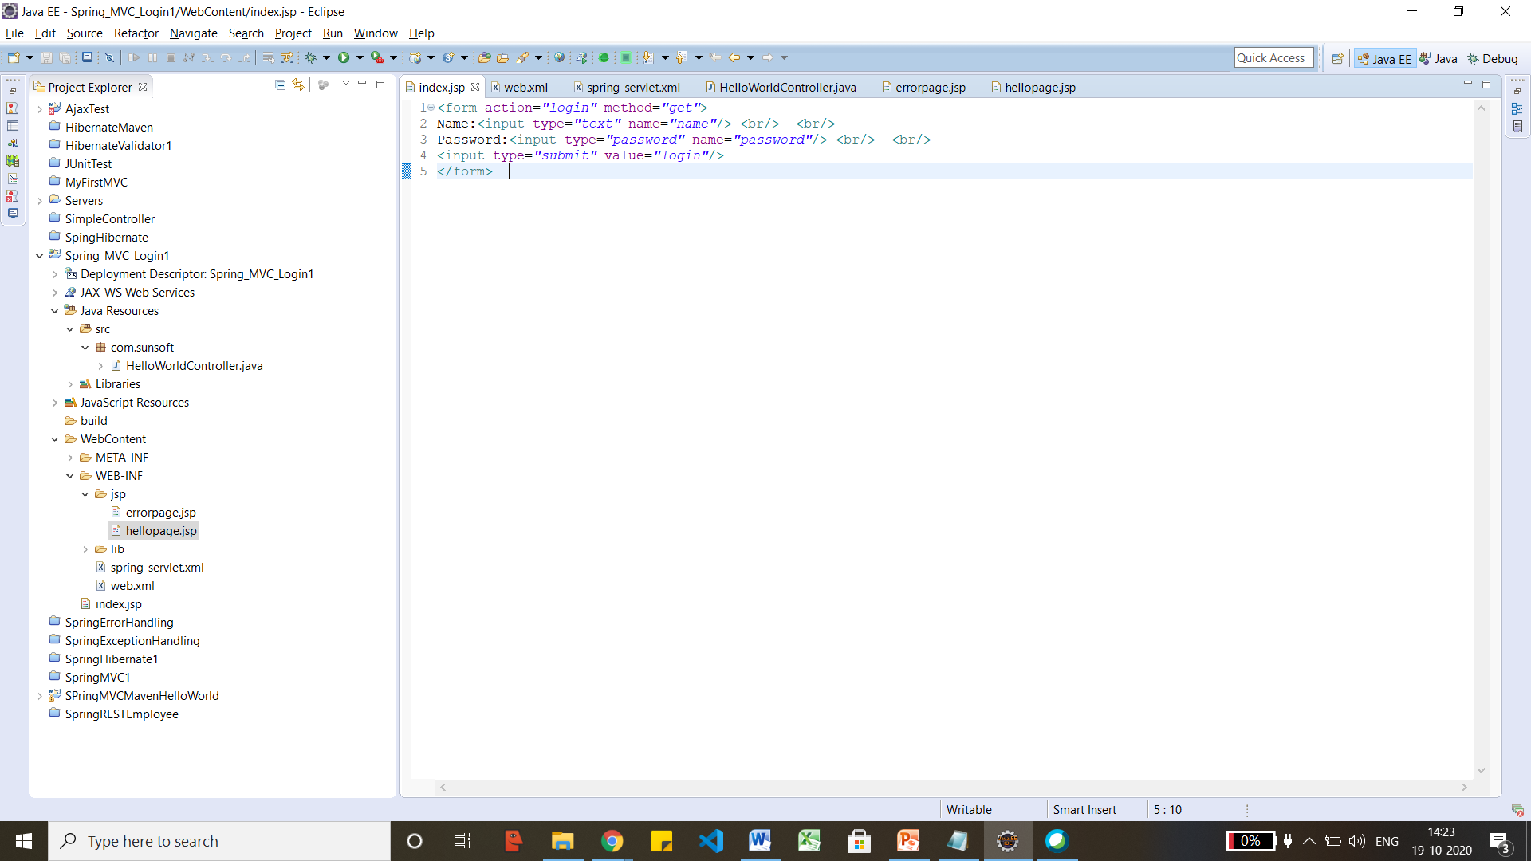
<?xml version="1.0" encoding="UTF-8"?>
<web-app version="2.5"
xmlns="http://java.sun.com/xml/ns/javaee"
xmlns:xsi="http://www.w3.org/2001/XMLSchema-instance"
xsi:schemaLocation="http://java.sun.com/xml/ns/javaee
http://java.sun.com/xml/ns/javaee/web-app_2_5.xsd">
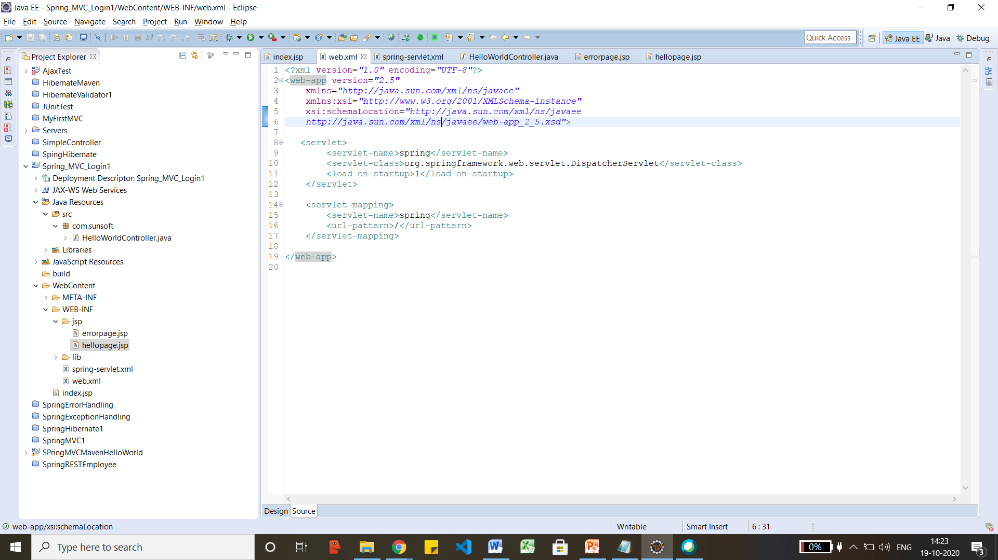

<?xml version="1.0" encoding="UTF-8"?>
<beans xmlns="http://www.springframework.org/schema/beans"
xmlns:xsi="http://www.w3.org/2001/XMLSchema-instance"
xmlns:p="http://www.springframework.org/schema/p"
xmlns:context="http://www.springframework.org/schema/context"
xsi:schemaLocation="http://www.springframework.org/schema/beans
http://www.springframework.org/schema/beans/spring-beans-3.0.xsd
http://www.springframework.org/schema/context
http://www.springframework.org/schema/context/spring-context-3.0.xsd">
